Customer Order Tracking
Android Blueprint Document

Mobile Project

Prepared For | Business Group
Prepared By | TBD
Date of Document | 4 April 2019
Release No: | V0.1

The materials presented in this document shall not be disclosed. No part of this document may be re-produced, in any form or by any means without permission from Averis Sdn Bhd.
Table of Content

1. CHANGE HISTORY 3
2. INTRODUCTION 4
2.1 ACCEPTANCE / SIGNATORY OF SPECIFICATION 4
2.2 PURPOSE OF DOCUMENT 5
2.3 INTENDED AUDIENCE 5
3. Form Automation 6
3.1 Background 6
3.2 SCOPE OF WORK 6
3.3 Definition of Terms 6
3.4 FORM DESIGN 7
3.4.1 Homepage 7
3.4.2 Login Page 7
3.4.3 System Process Flow 8
3.4.4 Marketing Proposal 9
3.4.4.1 Form 9
3.4.4.2 Available Actions 14
3.4.4.3 Result Panel 15
3.4.4.4 Filter Panel 15
3.4.4.5 Audit Log 15
3.4.5 Payment Request 16
3.4.5.1 Form 16
3.4.5.2 Available Actions 18
3.4.5.3 Result Panel 19
3.4.5.4 Filter Panel 19
3.4.5.5 Audit Log 20
3.4.6 Approval Matrix 20
3.4.7 Currency 21
3.5 OTHER REQUIREMENTS 22
3.5.1 Email Notification 22
3.5.2 Email Reminder 23
3.6 Mobility 24

CHANGE HISTORY

Date of Update | Updated By | Version | Change Description
Apr 04, 2019 | TBD | 1.0 | Documentation creation

INTRODUCTION

ACCEPTANCE / SIGNATORY OF SPECIFICATION

This document supersedes any previous document on the subject of the requirements of application and software functionality for the project.

Signature on this Business Blueprint document by authorized user representative indicates satisfaction and acceptance of this document as a description of the complete functionality required of the project. Any changes to the functional requirements described in this document will be noted as change requests and this document will be amended to reflect these changes.

Angie Lam
Marketing Manager

PURPOSE OF DOCUMENT

The primary purpose of this document is to capture the functional requirements of the Marketing Proposal , Payment Request. It represents the project deliverables to the users. The requirements documented here are the results of the requirements gathering phase. It represents the project deliverables to the users and also states the assumptions used in the design and development of the system by Averis Sdn Bhd.

Any changes, whatsoever in the requirements stated in this document will undergo a proper change control process and is subject to evaluation prior to implementation. Changes may incur additional time and cost should it be implemented.

INTENDED AUDIENCE

This document is intended for review by various user-groups within the user community with vested interests in this Project. These groups should check the validity of business assumptions, the accuracy of the business functions, outputs and the flow of processing logic described in the document.

When accepted, it will form the basis for detailed design and development of the system. This document is also meant for Averis Sdn Bhd in the design, development and testing phases of the system.

Form Automation

Background
Current paperwork system for Marketing is very tedious and requires multiple parties to scan, print and email multiple times.
After various scans, the original proposal / PRA becomes distorted and unreadable.
This process is tedious, not to mention time consuming.
To overcome this, an initiative to allow customers to track their respective orders has risen. This project will include developing an Android Application to be published on to the respective App Store for APRIL customers to download and use it where necessary.

SCOPE OF WORK

The following scope of work will be included as part of this project:
- Development of Android Application using Android Studio.
- Development of Web API.
- Development of admin portal to maintain the data.

Any changes on the above scope shall undergo a proper scope change control and may incur additional effort.

Definition of Terms

The following terminologies shall be used throughout this document:
- Originator – someone who raised the form.
- Approver – someone who either reviews, endorses, approves, or rejects the form.
- Report Viewer – someone who can access the reports page.
- Administrator – mostly IT personnel who can configure, support, and maintain the system.
- System – also known as Open Text Entity Model

ANDROID DESIGN

System Process Flow

The navigation between various screens in the application is as shown in the following diagram (Figure XXX):
Splash Screen
Welcome Screen
Outbound: Null
Inbound: OTP
Registration ID does NOT Exist
Registration Screen
Outbound: Email & Phono No.
Inbound: Activation Code (Partial)
Activation Screen
Outbound: Activation Code & IMEI no.
Inbound: Registration ID
Registration ID Exist
OTP Screen
Outbound: OTP
Inbound: Token ID
Tracking Screen with Banner
Outbound: Registration ID, IMEI no., Token ID & Tracking no.
Inbound: Order Details / Order List
Webview
List of Orders Screen
Outbound: Registration ID, IMEI no., Token ID & Tracking no.
Inbound: Order Details
Order Details Screen (Header + Items)
Order Item Details Screen
Session Expired Pop-up Dialog
Sales Order No. Exist
Sales Order No. Is Blank
Banner Selected
Figure 3-1: Android Screen Navigation

Screen Details

The following subsections will describe the functionality of each respective screen.

Note: Theme and layout shown in the picture below may be different from actual form.

Splash Screen

Upon launching the application at the beginning, a splash screen will be presented as an introduction screen to the user. In addition, the splash screen is designed to cover the entire screen of the mobile. Meanwhile, during the launching of the splash screen, an API will be called to retrieve the banner information and is stored in the cache for later use when the user reaches the Tracking Screen with Banner page. The splash screen for the current design is as shown below:



Registration Screen

If the user has never registered before upon installing the app on the phone (uninstalling and reinstalling the app back into the phone also requires the user to re-register), the user will then be taken to the Registration Screen page.

For android phones with API level more than or equal to 26, the user will be required to Allow the phone to grant permission for the app to make and manage phone calls. While for android phone with API lower than 26, the user will not be required to do so. You may refer to Table xxx below which shows the list of API level associated with the Android Version and Codename where necessary. The permission granted here is necessary for the app to be able to retrieve the Imei number of the phone to be used for verification purposes to ensure that the application can only be used by a single user per email and phone number login combination. If the user chooses to deny this permission at any point in time when using this app, the user will be prompted with a dialog screen indicating to the user that he/she is required to allow the permission before proceeding to call the web API. This is necessary as the web API will always require the Imei number for verification purposes (except during Registration).

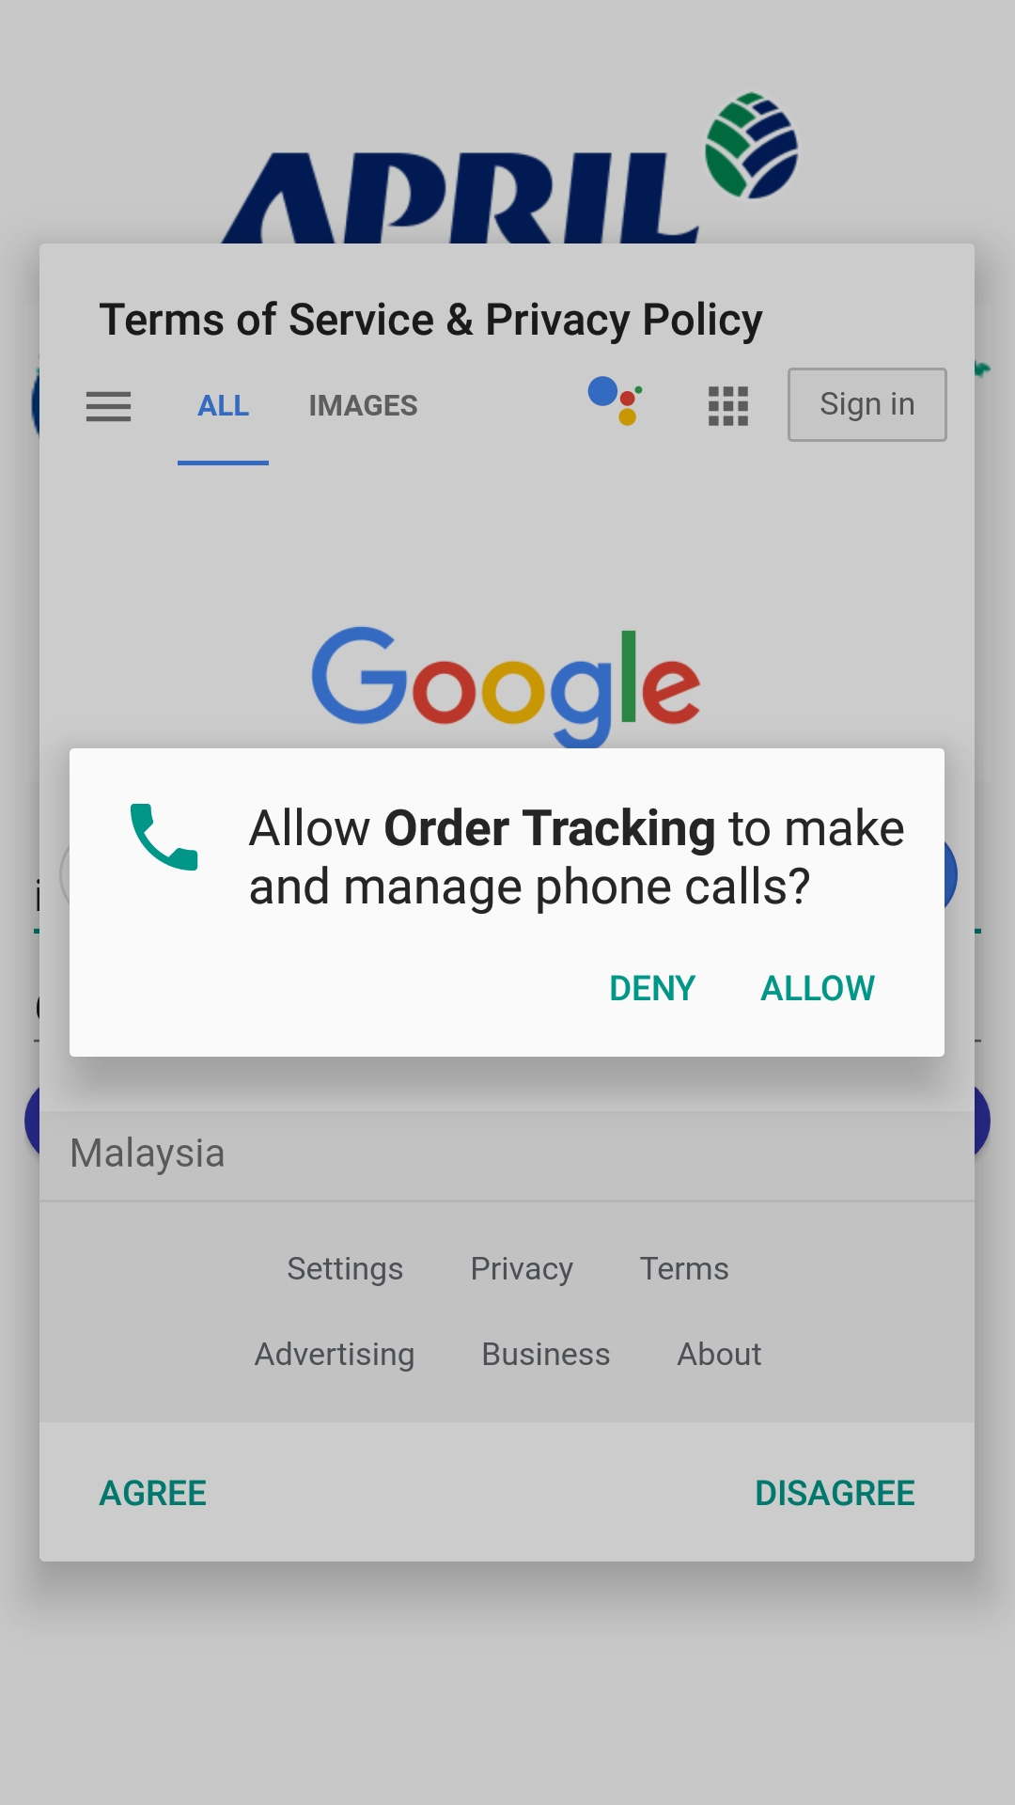

Codename | Version | API level
Pie | 9 | API level 28
Oreo | 8.1.0 | API level 27
Oreo | 8.0.0 | API level 26
Nougat | 7.1 | API level 25
Nougat | 7.0 | API level 24
Marshmallow | 6.0 | API level 23
Lollipop | 5.1 | API level 22
Lollipop | 5.0 | API level 21
KitKat | 4.4 - 4.4.4 | API level 19
Jelly Bean | 4.3.x | API level 18
Jelly Bean | 4.2.x | API level 17
Jelly Bean | 4.1.x | API level 16
Ice Cream Sandwich | 4.0.3 - 4.0.4 | API level 15
Ice Cream Sandwich | 4.0.1 - 4.0.2 | API level 14
Honeycomb | 3.2.x | API level 13
Honeycomb | 3.1 | API level 12
Honeycomb | 3.0 | API level 11
Gingerbread | 2.3.3 - 2.3.7 | API level 10
Gingerbread | 2.3 - 2.3.2 | API level 9
Froyo | 2.2.x | API level 8
Eclair | 2.1 | API level 7
Eclair | 2.0.1 | API level 6
Eclair | 2.0 | API level 5
Donut | 1.6 | API level 4
Cupcake | 1.5 | API level 3
(no codename) | 1.1 | API level 2
(no codename) | 1.0 | API level 1

After getting through the permission dialog screen for android API level more than or equal to 26, the user will then be able to see another dialog screen (WebView) containing the Terms of Service and Privacy Policy which is coming from a website. For android API level less than 26, the first thing that user should see when coming into the Registration Screen is the Terms of Service and Privacy Policy dialog since no permission is required to be granted. If the user selects on Disagree, the app will close. While, if the user selects on Agree, the Terms of Service and Privacy Policy will be dismissed and the user can proceed with registering.
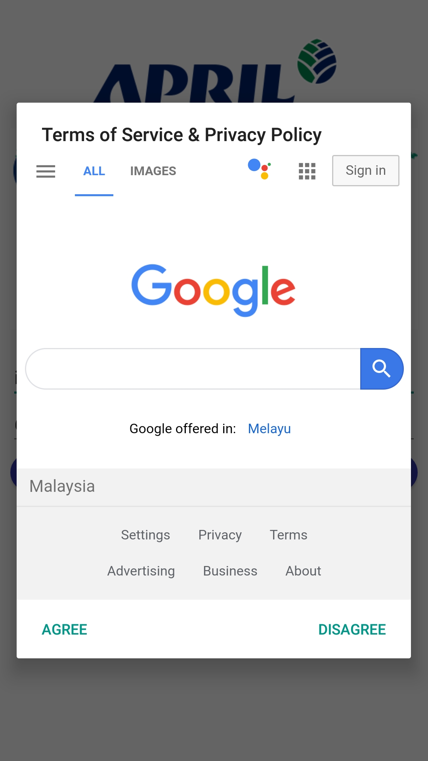
During the registration, the user will have to enter the registered combination of Email Address and Phone Number correctly before proceeding to the next screen upon selection of the Register button. In the event that the user did not fill-up the Email Address and/or Phone No. before selecting on the Register button, the user will be prompt with an error indicating to user that these fields are required to be filled.

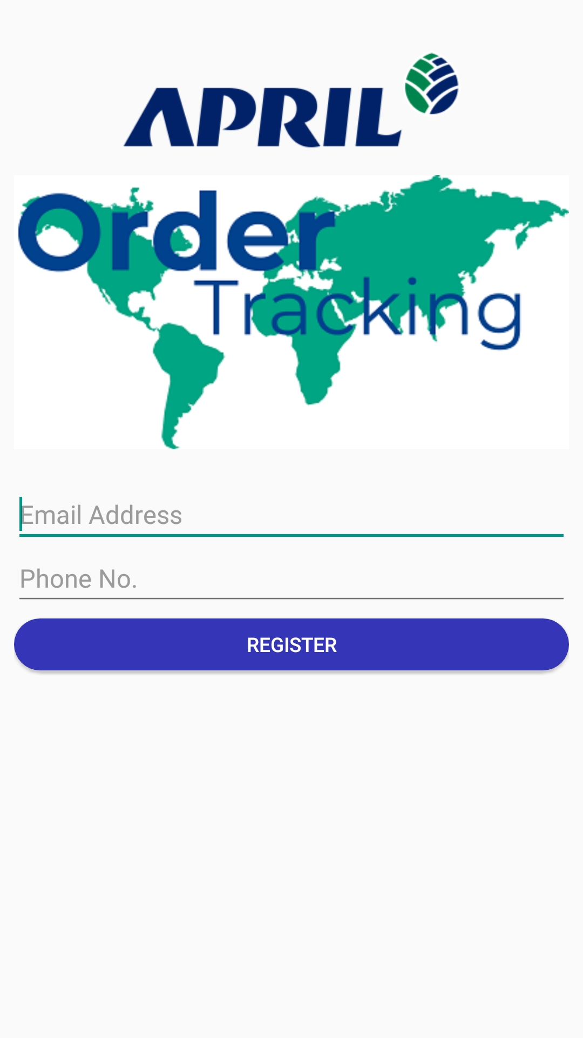

Error Shown when Email Not Filled | Error Shown when Phone Number Not Filled
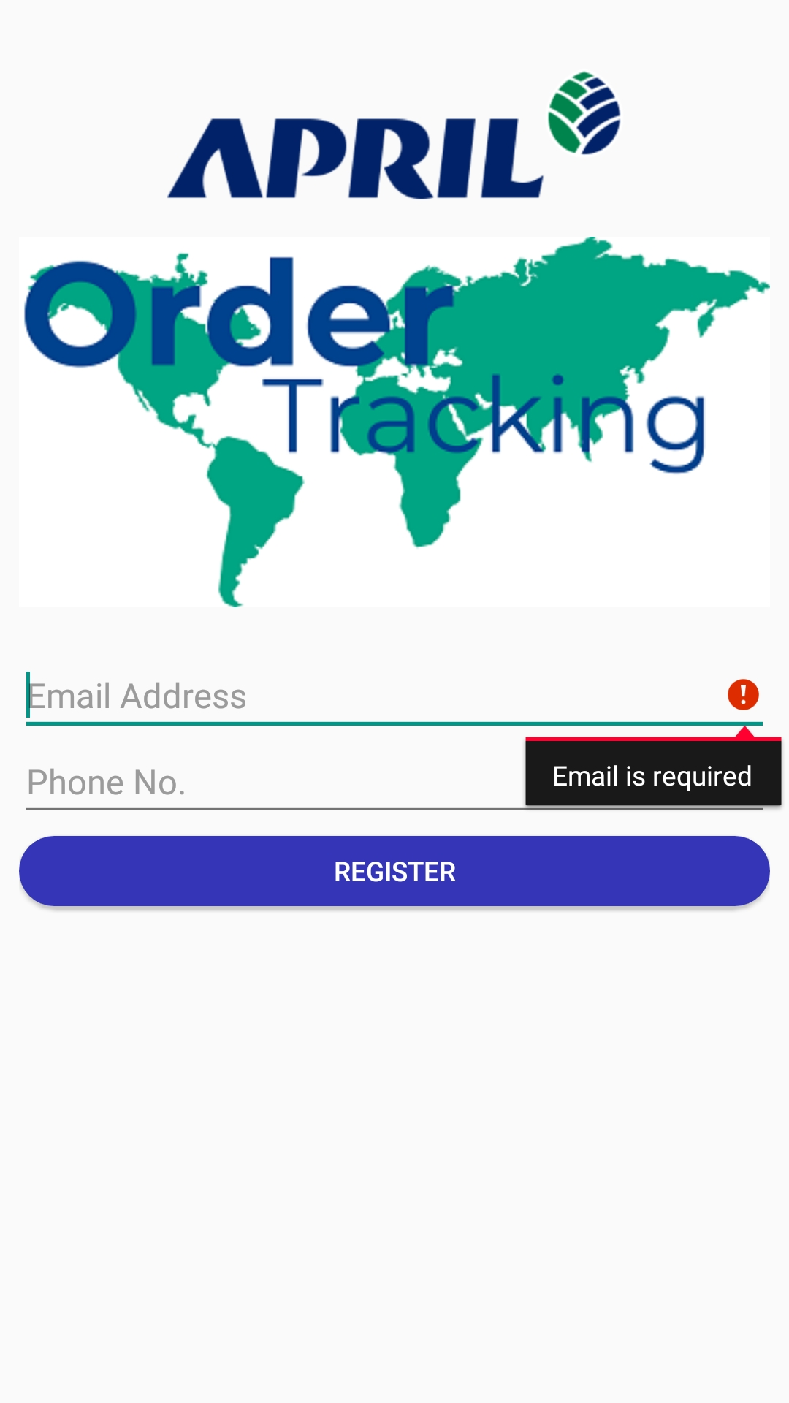 | 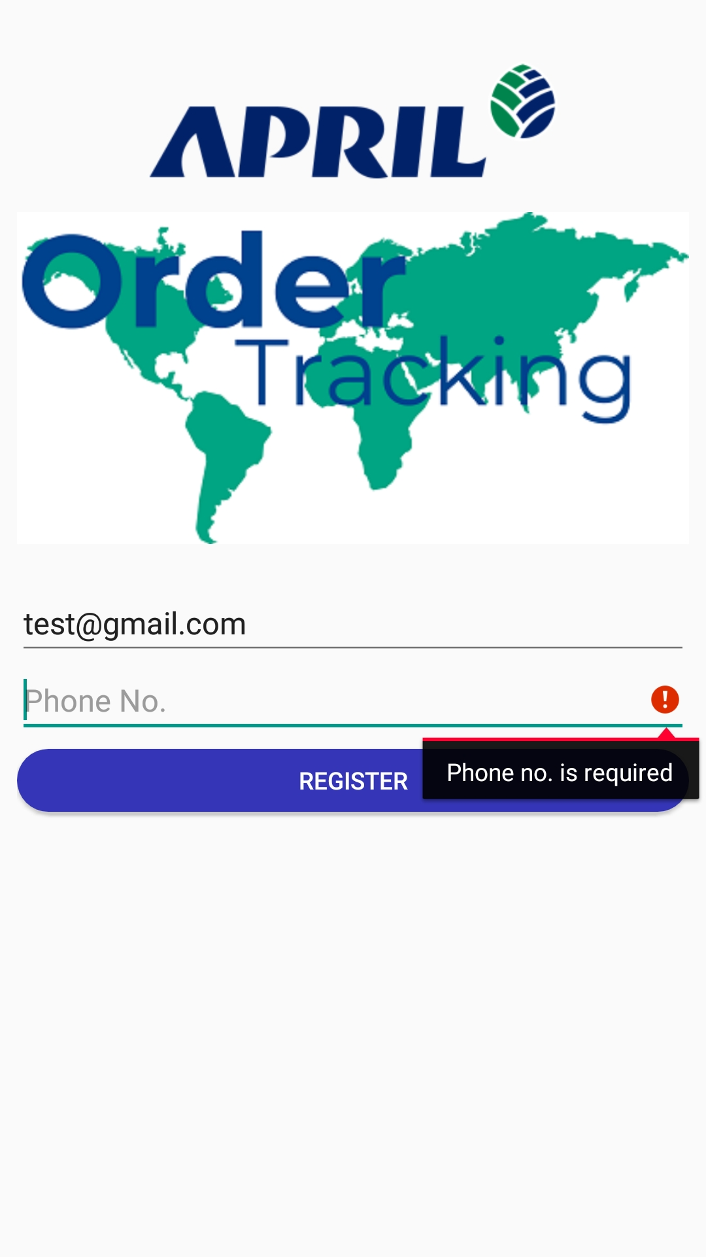

Activation Screen

Upon successfully registering, the user will now be displayed with the Activation Screen. In addition to successfully registering, an encrypted string will be stored in the Shared Preference of the phone to be used later when activating. Hence in order for the user to be successfully activated, the user will have to enter the Activation Code that will be sent to the user’s phone number (as per the phone number used during registration) and select on the Activate button. By doing so, the activation code along with the encrypted string stored earlier in the Shared Preference and the Imei number of the respective phone will be sent through the web API for verification. If the user selects on Activate, without providing any activation code, a toast message will be shown at the bottom indicating to the user that the activate code field cannot be empty. Once verified, the user will then be taken to the Welcome Screen. On the other hand, if the user has failed to verify, a dialog message will appear indicating to the user that the user has failed to enter the correct activation code. Apart from that, the user may select on the Resend Activation Code to get another new activation code through SMS where necessary.

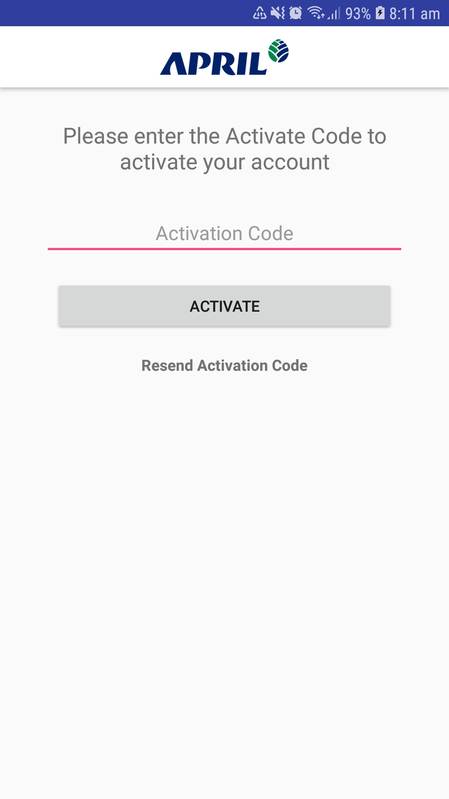

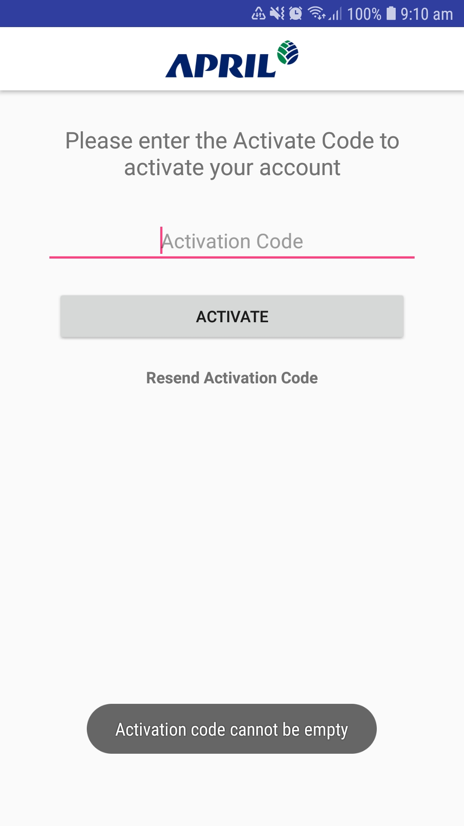

Welcome Screen

During the loading of the Welcome Screen, a progress bar indicator will be shown at the bottom of the screen to indicate to the user the loading progress. The background process that results in this loading progress includes checking the connectivity of the device to the internet, passing the values to the Web API and then retrieving the values back from the Web API, and storing the response of the Web API to be used in the next screen. If the all progress is successfully executed, the user will then be taken to the next screen; OTP Screen.

If the WiFi is not connected to any router or mobile data is not switched on, the user will be prompted with a dialog box to notify user to connect to the internet before proceeding. Once the user selects on the Try Again button on the dialog box, the app will then restart.

In addition, if the Web API response returns any error code, the respective dialog box will pop up. Upon dismissing the dialog box with a positive response, the respective action will happen with respect to the type of error code.

OTP Screen

At the OTP Screen, the user will be required to enter the OTP as per the 6 digit code displayed on the screen. If the user enters the 6 digit code incorrectly for 3 times, a new OTP will be generated from the Web API for the user to reenter again. Upon successfully entering the 6 digit code correctly, the user will then be routed to the Tracking Screen.

Tracking Screen with Banner

In the Tracking Screen, it will consist of an auto-sliding banner at the top of the screen, and in the middle of the screen, the user will be allow to specify or leave the Tracking Number field blank before selecting on the Track button.

If the user enters a specific order number, a Web API will be called. If the order number relating to the customer ID does not exist from the backend, a toast message will be shown to the user that the order is not found. On the other hand if it does exist, the user will be routed to the next screen; Order Details Screen.

However, if the Track Order Number field is blank and the Track button is selected, a list of orders relating to the user’s customer ID will be shown. Further explanation description on this list of orders will be described in Section 3.4.2.7 – List of Orders Screen.

Apart from that, the user may also choose to interact with the banner by selecting on any of the banner. By doing so, the user will be taken to another screen which is a full screen Web View showing a webpage with respect to the redirected URL on the selected banner.

List of Orders Screen

In the

OTHER REQUIREMENTS

Email Notification

System will send email notification based on the following approval action:
Approval Action | Description
Submission | Email notification will be sent out to the first approver once the form is submitted.
Approval | Email notification will be sent out to the next approver once the form is approved by the previous approver.
Rework | Email notification will be sent out to the originator should the form require changes.
Reject | Email notification will be sent out the originator should the form be rejected at any point in time
Fully Approved | Email notification will be sent out to the originator and all involved approver once the form is completely approved.

Email notification will contain the following:
- To – email address of the approver.
- From – system’s email address.
- Subject – configurable but should contain the following:
  - Form Status (Pending Approval, Rejected, Fully Approved and Rework )
  - Form Code (e.g. MKTG - 18 - CSPM - SG - 01)
- Body – configurable but should contain the following:
  - Form Details
  - Link

Email Reminder

To avoid forms from being pending for a long period of time, an email reminder will be sent out to the current approver every day, 1 day (24 hours) after the form was assigned to the approver. The day (3 days) on when the first email reminder will be sent out will be configurable.

Mobility

Form M System can be accessible through company provided MDM service (for selected personnel only) which is running under Blackberry Access.

Users who are entitled to use MDM services provided by company shall install “Blackberry Access” application to their own device to access the web address of Form M system which will be shared upon go-li

